**OS LAB 11**

**NAME: Zainab-Binte-Hassan ID: FA17-BECE-0020**

**TASK1: FCFS**

**CODE:**

#include<stdio.h>

#include<stdlib.h>

void main()

{

int bt[20],p[20],wt[20],tat[20],i,j,np,total=0,pos,temp;

float avg_wt,avg_tat;

printf("Enter number of process:");

scanf("%d",&np);

printf("\nEnter Burst Time:\n");

for(i=0;i<np;i++)

{

printf("p%d:",i+1);

scanf("%d",&bt[i]);

p[i]=i+1;

}

//sorting burst time in ascending order using selection sort

for(i=0;i<np;i++)

{

pos=i;

for(j=i+1;j<np;j++)

{

if(bt[j]<bt[pos])

pos=j;

}

temp=bt[i];

bt[i]=bt[pos];

bt[pos]=temp;

temp=p[i];

p[i]=p[pos];

p[pos]=temp;

}

wt[0]=0;

//waiting time for first process will be zero

//calculate waiting time

for(i=1;i<np;i++)

{

wt[i]=0;

for(j=0;j<i;j++)

wt[i]+=bt[j];

total+=wt[i];

}

avg_wt=(float)total/np; //average waiting time

total=0;

printf("\nProcess\t Burst Time \tWaiting Time\tTurnaround Time");

for(i=0;i<np;i++)

{

tat[i]=bt[i]+wt[i]; //calculate turnaround time

total+=tat[i];

printf("\np%d\t\t %d\t\t %d\t\t\t%d",p[i],bt[i],wt[i],tat[i]);

}

avg_tat=(float)total/np; //average turnaround time

printf("\n\nAverage Waiting Time=%f",avg_wt);

printf("\nAverage Turnaround Time=%f\n",avg_tat);

}

**RESULT:**

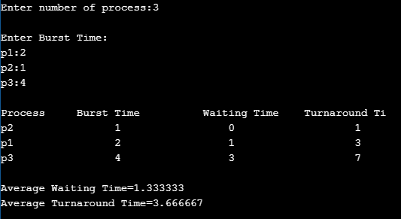

**TASK2:**

**SJF WITH ARRIVAL TIME**

**CODE:**

#include<stdio.h>

int main()

{

int i,n,p[10]={1,2,3,4,5,6,7,8,9,10},min,k=1,btime=0;

int bt[10],temp,j,at[10],wt[10],tt[10],ta=0,sum=0;

float wavg=0,tavg=0,tsum=0,wsum=0;

printf("\nEnter the No. of processes :");

scanf("%d",&n);

for(i=0;i<n;i++)

{

printf("\tEnter the burst time of %d process :",i+1);

scanf(" %d",&bt[i]);

printf("\tEnter the arrival time of %d process :",i+1);

scanf(" %d",&at[i]);

}

/*Sorting According to Arrival Time*/

for(i=0;i<n;i++)

{

for(j=0;j<n;j++)

{

if(at[i]<at[j])

{

temp=p[j];

p[j]=p[i];

p[i]=temp;

temp=at[j];

at[j]=at[i];

at[i]=temp;

temp=bt[j];

bt[j]=bt[i];

bt[i]=temp;

}

}

}

/*Arranging the table according to Burst time,

Execution time and Arrival Time

Arrival time <= Execution time

*/

for(j=0;j<n;j++)

{

btime=btime+bt[j];

min=bt[k];

for(i=k;i<n;i++)

{

if (btime>=at[i] && bt[i]<min)

{

temp=p[k];

p[k]=p[i];

p[i]=temp;

temp=at[k];

at[k]=at[i];

at[i]=temp;

temp=bt[k];

bt[k]=bt[i];

bt[i]=temp;

}

}

k++;

}

wt[0]=0;

for(i=1;i<n;i++)

{

sum=sum+bt[i-1];

wt[i]=sum-at[i];

wsum=wsum+wt[i];

}

wavg=(wsum/n);

for(i=0;i<n;i++)

{

ta=ta+bt[i];

tt[i]=ta-at[i];

tsum=tsum+tt[i];

}

tavg=(tsum/n);

printf("\n RESULT:-");

printf("\nProcess\t Burst\t Arrival\t Waiting\t Turn-around" );

for(i=0;i<n;i++)

{

printf("\n p%d\t %d\t %d\t\t %d\t\t\t%d",p[i],bt[i],at[i],wt[i],tt[i]);

}

printf("\n\nAVERAGE WAITING TIME : %f",wavg);

printf("\nAVERAGE TURN AROUND TIME : %f",tavg);

return 0;

}

**RESULT:**

